**JAVA Exercício Conteúdo 24**

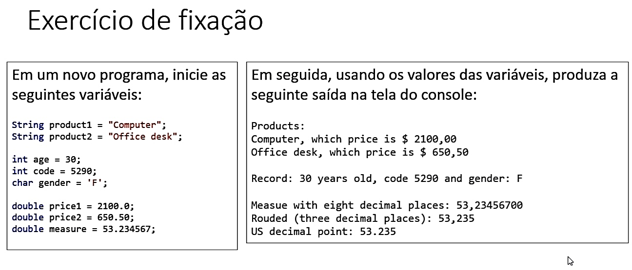

import java.util.Locale;

public class Main {

public static void main(String[] args) {

String product1 = "Computer";

String product2 = "Office desk";

int age = 30;

int code = 5290;

char gender = 'F';

double price1 = 2100.0;

double price2 = 650.50;

double measure = 53.234567;

System.out.println("Products:");

System.out.print(product1);

System.out.print(", which price is $ ");

System.out.printf("%.2f%n", price1);

System.out.print(product2);

System.out.print(", which price is $ ");

System.out.printf("%.2f%n", price2);

System.out.println(" ");

System.out.print("Record: ");

System.out.print(age);

System.out.print(" years old, code ");

System.out.print(code);

System.out.print(" and gender: ");

System.out.println(gender);

System.out.println(" ");

System.out.print("Measue with eigt decimal places: ");

System.out.printf("%.8f%n", measure);

System.out.print("Rouded (tree decimal places): ");

System.out.printf("%.3f%n", measure);

System.out.print("US decimal point: ");

Locale.setDefault(Locale.US);

System.out.printf("%.3f%n", measure);

Products:

Computer, which price is $ 2100,00

Office desk, which price is $ 650,50

Record: 30 years old, code 5290 and gender: F

Measue with eigt decimal places: 53,23456700

Rouded (tree decimal places): 53,235

US decimal point: 53.235